**Jose L. Delgado**

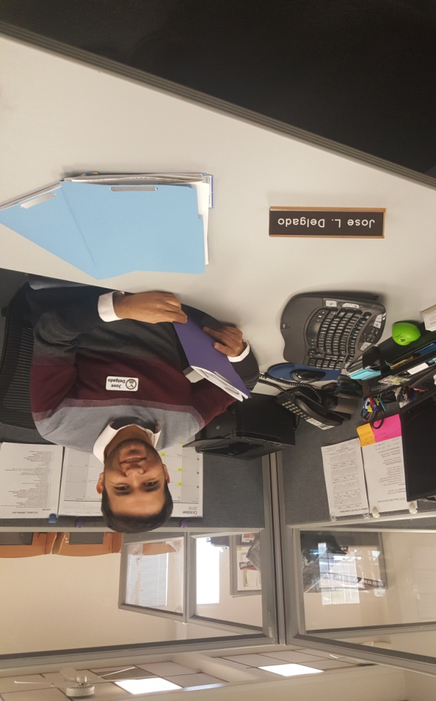

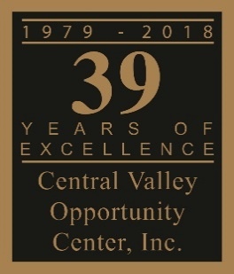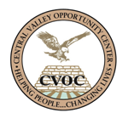

**CENTRAL VALLEY OPPORTUNITY CENTER**

My name is Jose L. Delgado. I am from Zacatecas, Mexico and I arrived to The United States with a Tourist Visa in 2014. Like many people, I decided to chase the American dream, and start earning dollars, “cueros de rana” as my dad used to call them. At the beginning, thinking it would be easy; I was wrong.

I came to Madera, CA because part of my mom’s family lives here. However, I did not have the legal right to work in this country. Since I got to my aunt’s house, I started working illegally as a farm labor. The work was hard. I never found any interest working in agriculture, even though in Mexico; my parents have been in agriculture their whole lives. I always wanted to go to school, and pursue higher level of education instead.

Working in the fields had some advantages, it was not bad at all, and I met good people who became my support system. In many ways, we were related to one another, and I realized that we all share the same purpose for being in this country; to get a better life. In 2017, I was able to get an Employment Authorization, and I decided to look for better job opportunities. Not all the people, in the United States are fortunate to work legally, so I wanted to take full advantage.

Even though English would be a barrier, I was determined to prosper. I enrolled into ESL classes, and always gave 100 % to improve my English. I was introduced to Central Valley Opportunity Center by my roommate, and although I was skeptical of the “free training” as everything in this country is really expensive, I applied! To my surprise, I qualified, and I was soon enrolled in General Business Occupations course.

After completing my GBO training, I went back to work in the fields because I was in need of money. A month later, CVOC opened the Workforce Services Representative position; I applied, interviewed, and 2 weeks later I got the job! Now, it has been a year, and I am still working with CVOC, helping people to have the chance of a better future, just as I got it. Opportunities in life are rare, I like to think that everybody has the right time to make great decisions and grow up, but sometimes, we need to find the right sources. CVOC was my source, it has been the source for many people, and I am really grateful because Central Valley Opportunity Center changed my life for the better.